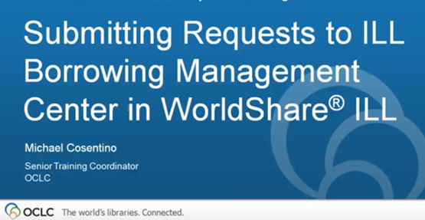

Portland Public Library is your group administrator aka ILL Borrowing Management Center.

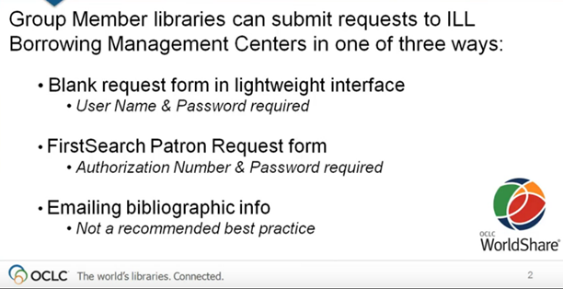

Blank request form: Accessed through the custom web address that was provided to you by the Portland Public Library. This is the “lightweight interface”. PPL also provided you with a username. The password was/will be created by your library.
This is the preferred method of requesting. This will allow for the most efficient processing while getting the item to your patron in the fastest way possible.

First Search patron request form: If you have been utilizing FirstSearch you may continue to place your requests via the patron form there. This should be a secondary means of requesting. Portland Public Library does not have access to your FirstSearch information. You would already have your authorization number and password.

Email requests: should only be used if you experience technical difficulties with other methods. See the section on ‘Troubleshooting’.

Browser Requirements:
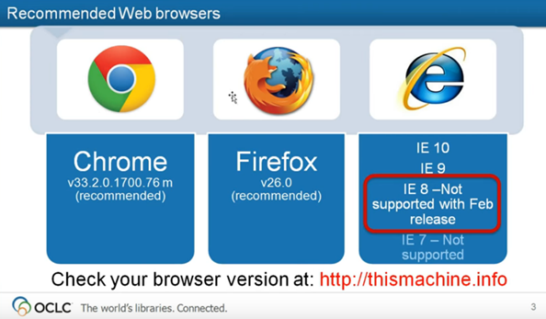

The Portland Public Library uses Firefox.

Workflow:
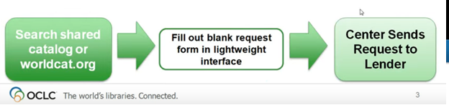

- Go to Worldcat.org:

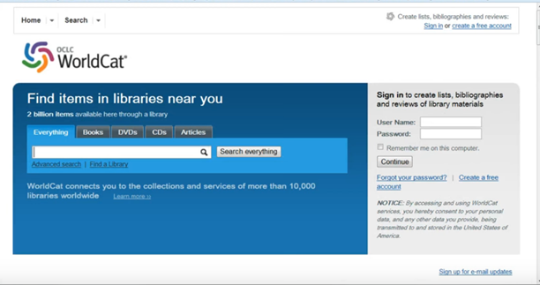

Conduct your search: 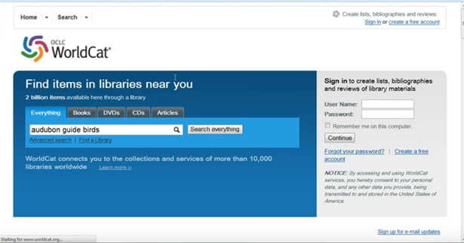

Locate your item in the search results or refine your search parameters:

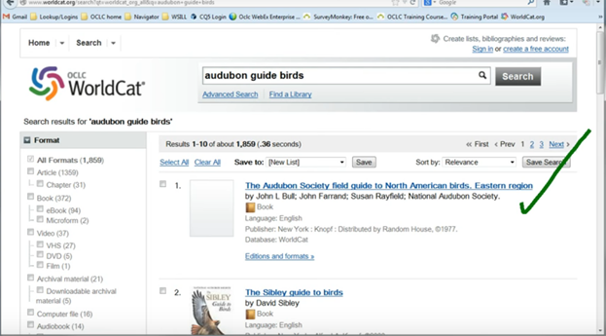

Click on the title of the item you want to request:
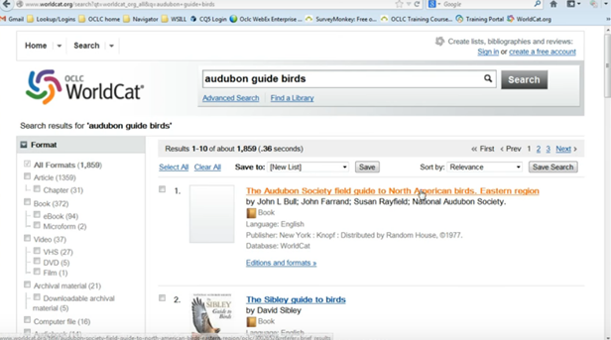

Open your custom web address/ user interface that was provided to you:
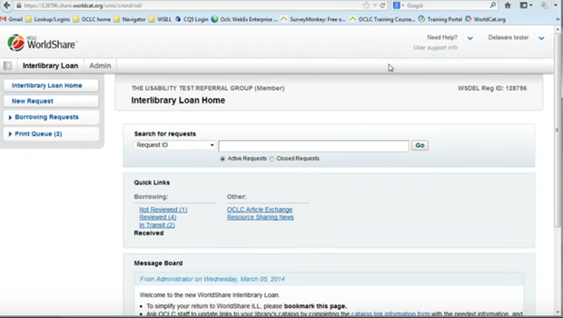

Choose the “New Request” option to open a blank request form:
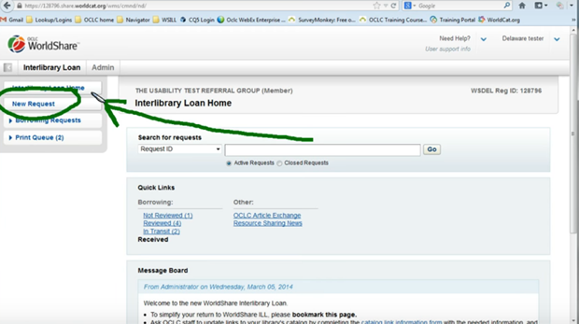

Copy title, author, and other citation information to paste into your blank request form:
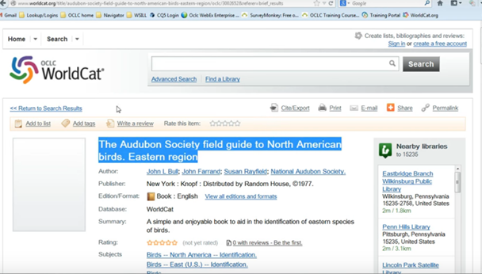

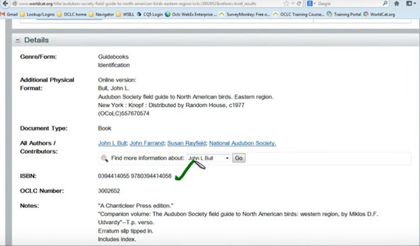

You should try to include an ISBN or OCLC number with each request. These can be found closer to the bottom of WorldCat records. Leaving them off increases the amount of time it takes to process the request for your patron. If you leave both of these fields blank Portland staff will have to locate them, creating a delay in processing. Due to the number of requests that Portland processes, leaving information out could mean that your request doesn’t make the cut off that day and is processed the following business day. (The ILL office closes each Friday at 4 pm EST and does not re-open until Monday morning.)
The ‘Request Details” section of the form is where you can paste your citation information - Copy and paste information from Worldcat.org into the corresponding fields of the blank request: 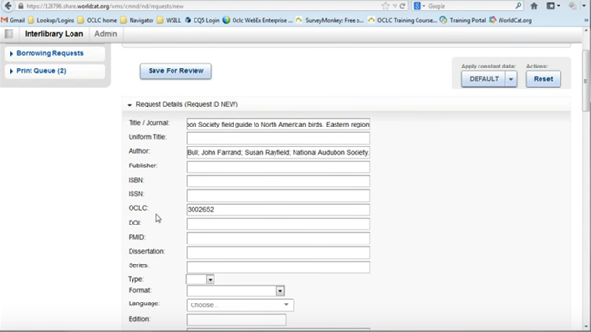
The next step is to add your ‘constant data’. This is information that you utilize often and want to add to your request without manually entering it every time. Choose either “LOAN” or “COPY”.
The “Borrowing Library” area is where your shipping information will automatically populate based on the ‘constant data’ option you choose. This is the address that your patron items will be sent to. If it is not correct or not populating, please contact Portland Public Library either via email at ill@portlib.org or via phone at 207-871-1735.
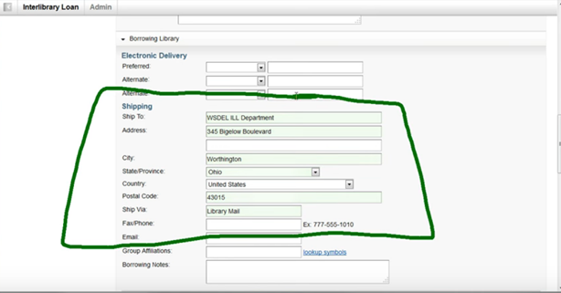

Once constant data has been chosen the “Patron information” section will show your library name, library card #, district (SMLD) and other information regarding your library:
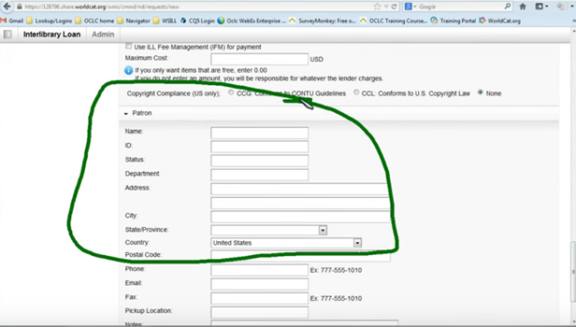

Portland Public library can set up ‘constant data’ records for various item types, branch locations, etc.
For example, if you want photocopies sent to your PO Box and physical items sent to your library you can have two “constant data” profiles to achieve this. Or, if you have a branch location a ‘constant data’ profile can be set up for your main branch and another one for your off-site location.
Even if you only have one shipping address you MUST apply your ‘constant data’ to each request. This affects how your request appears when it arrives in Portland. If your constant data has not been applied Portland will have to manually enter it which slows down the processing of your request.
Choose the ‘constant data’ profile that corresponds with the type of request you are placing:
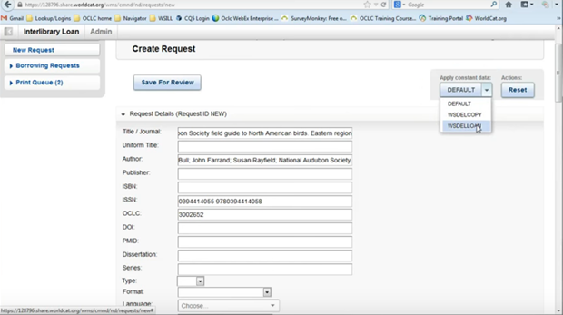
In this example choosing the “Loan” constant data will set the request type to “Loan”:
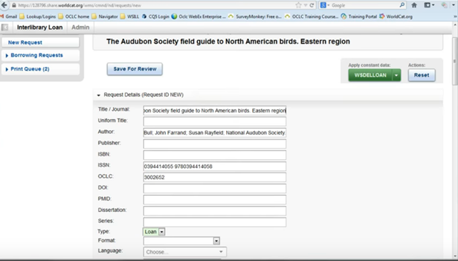

The selection will then apply all of the borrowing address, shipping address, and billing information that you want to appear on every loan request that you make.
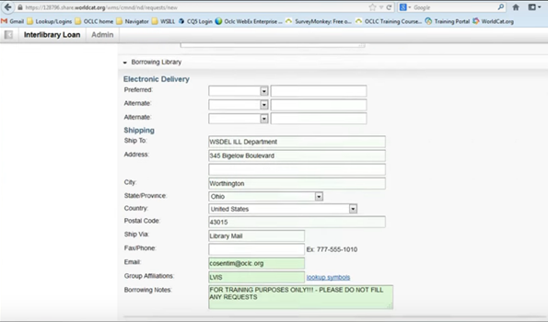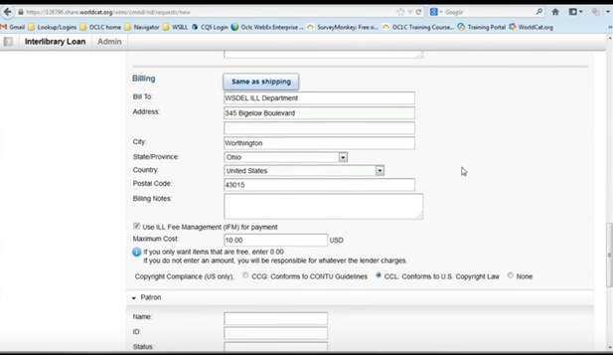

You may enter any notes you wish Portland to see in the “Billing Notes” field or the “Notes” field.
You do not need to put your patron name, or phone number or anything you don’t wish Portland Public Library to see. If you only want to put your patron library card number in the notes field so that you can identify your patron when the item arrives that is fine.
Once you have finished entering your notes your request is ready to be sent to the management center for processing.
Click “Save for Review”
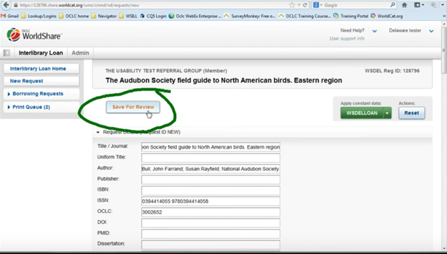

An interlibrary loan request number will be assigned to your request and place it in a ‘reviewed’ queue. This means that your library has reviewed and saved the request.
Portland will locate lenders for the request and send it along to them. We are able to contact a maximum of 15 lenders at a time. If there are more than 15 lenders available and your request is “unfilled” you may re-submit asking for the next 15 using the ‘Note’ field. If your request was unfilled because the item is “too new” or “checked out” please feel free to try again in a few weeks or months.

If you are using FirstSearch to locate items:
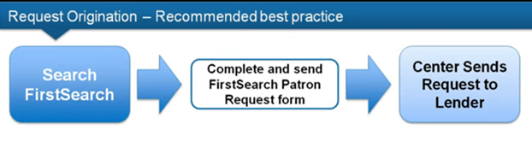
Go to FirstSearch:
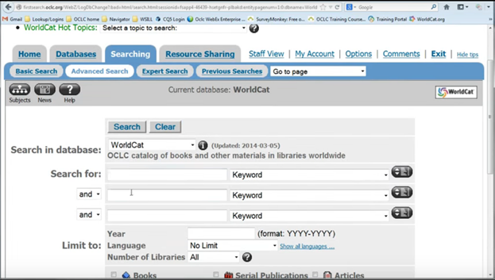

Enter your search parameters :
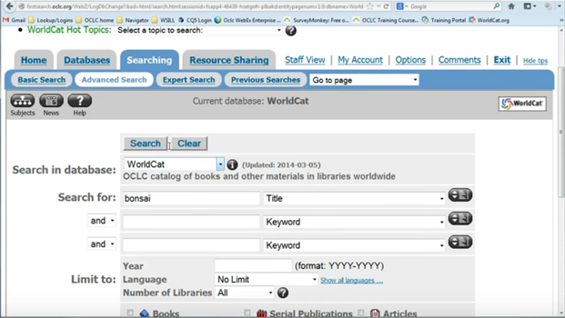

Click ‘ Search’:
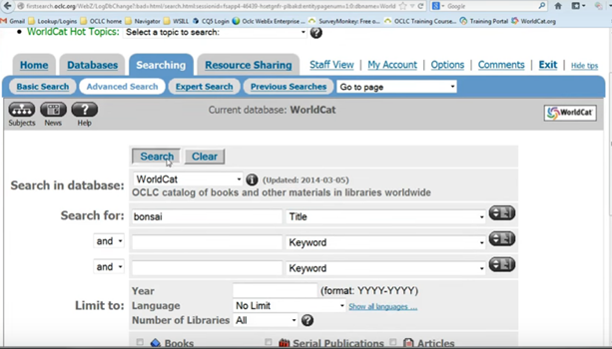

Locate your item in the search results:

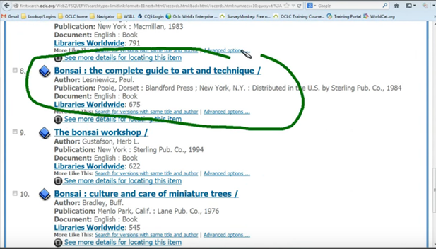

Click on the title:

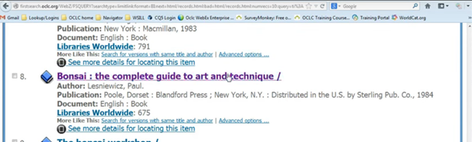

This will bring you to the detailed record:
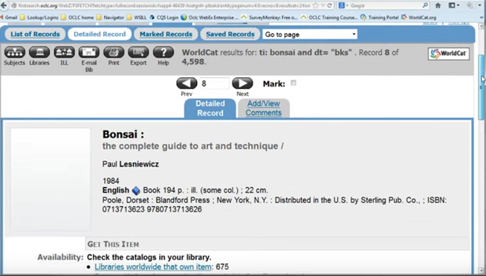

Here you will see a link to borrow the item via interlibrary loan:

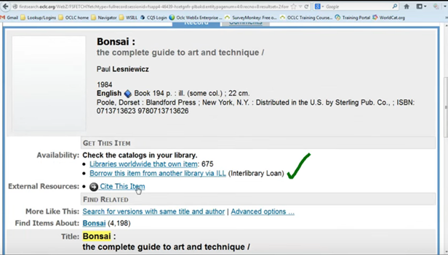
Click on the “borrow this from interlibrary loan” link & this will bring you to the patron request form. Complete your information and click “submit”
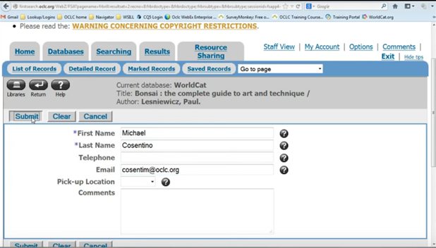
You should then get a confirmation message stating “your resource sharing request was sent successfully”.
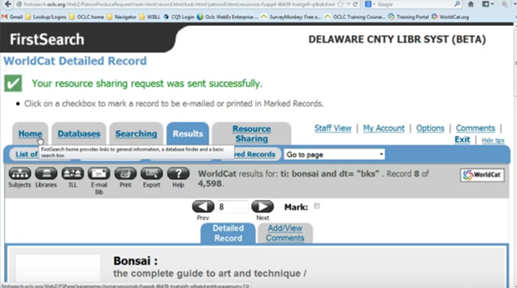

Any request placed through a FirstSearch blank form will appear in your “not reviewed” queue.
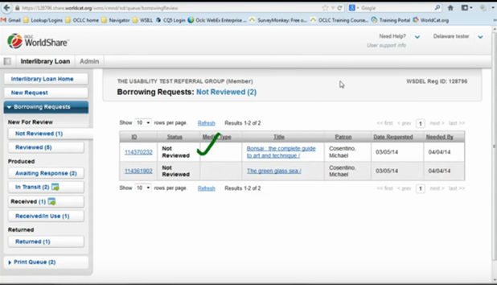
You can then click on the request to open it and add your constant data.

TROUBLESHOOTING:

If WorldShare ILL is not working:
Email your request: *** Only use if WorldShare ILL is not available ***
There are 3 ways to email your request.

- FIRSTSEARCH: In First Search there is an ‘email bib’ button once you have selected an item.– click it.

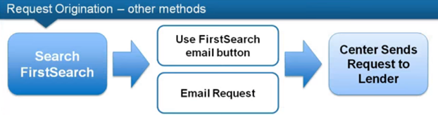

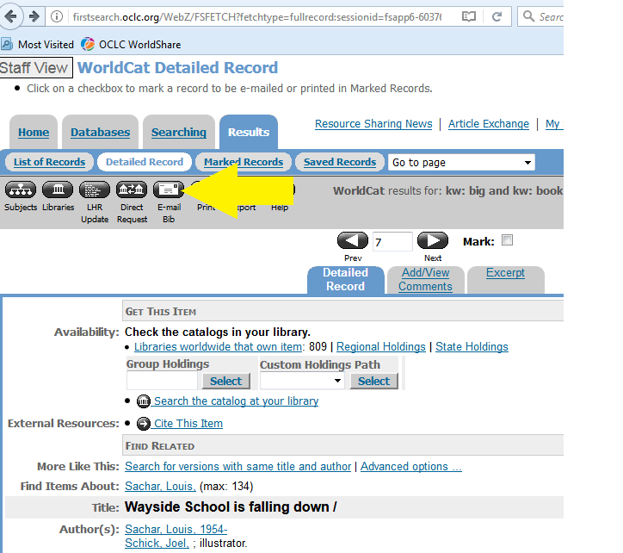

This will bring you to the below form – please complete and email to ill@portlib.org
Subject: ILL request
Notes: anything important that you wish to communicate with ILL staff.
Ex. Max cost $10

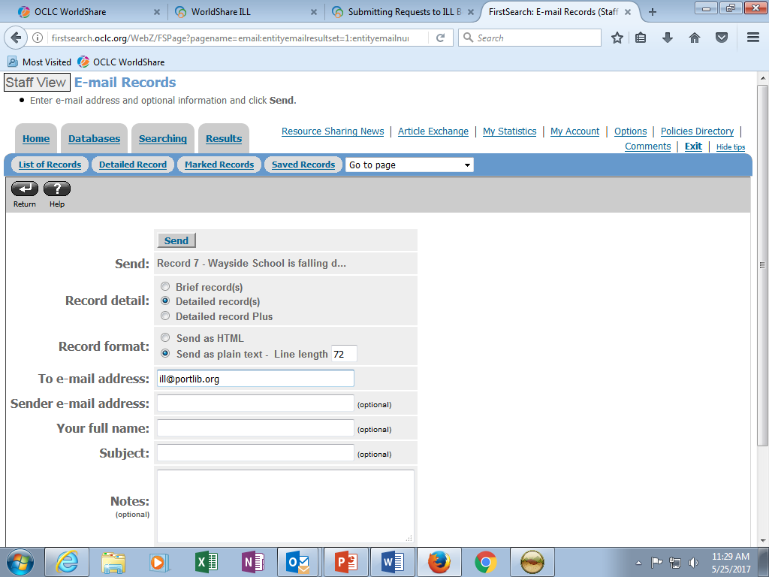
You will see a confirmation message letting you know your request has been submitted.
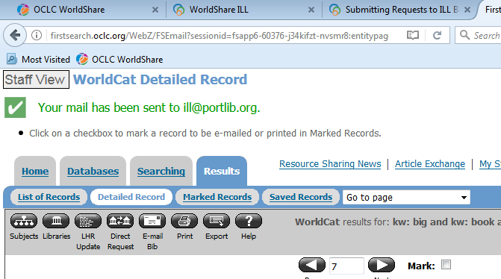

- WORLDCAT.ORG:

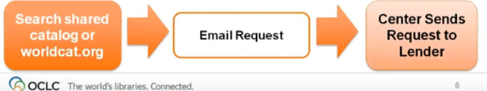

In WorldCat there is an “email” button above the record on the right hand side.
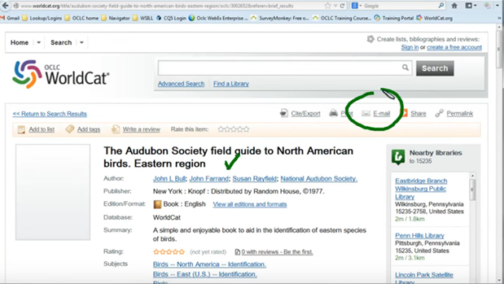
Clicking the ‘email’ button will open up a form: 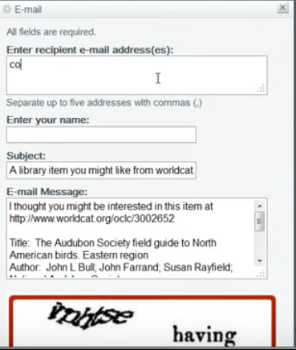
Complete the following information:
Receipient email address : ill@portlib.org
Name: your library name
Subject: ILL request
Email message – item info and any notes that you want ILL staff to see.
You will need to complete the Captcha
You should then receive confirmation that your request was submitted:
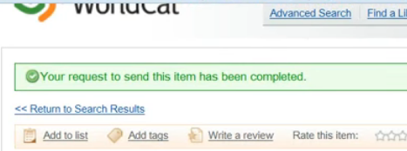

- Email ill@portlib.org directly with as much information as you can.

You may always contact OCLC Support with any questions:

