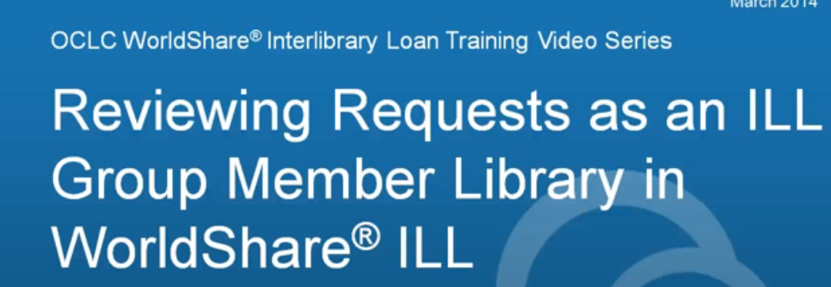

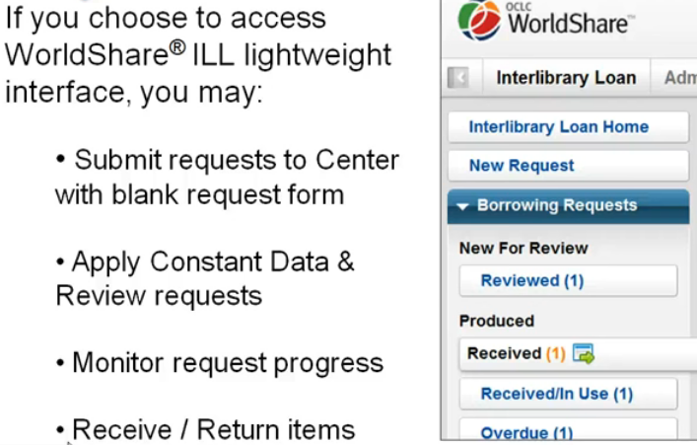

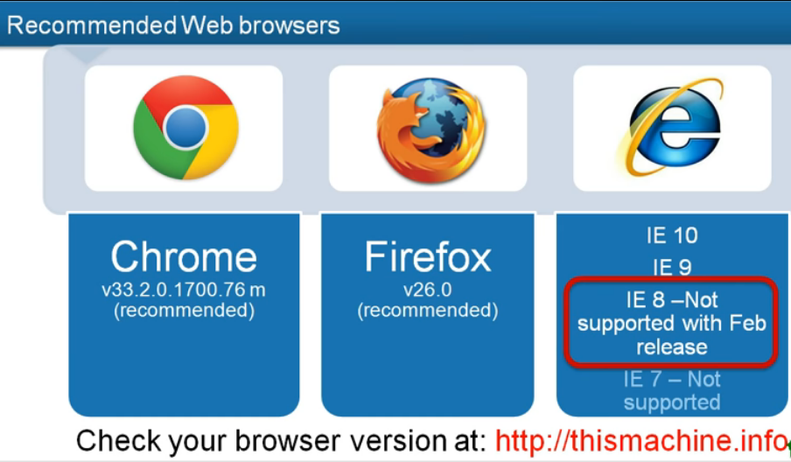

Workflow – this is what happens once your management center receives your request:
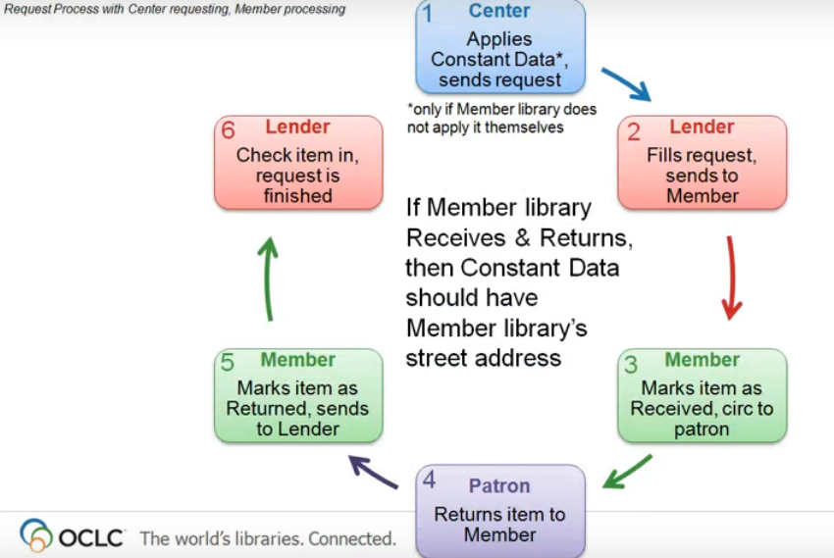
How you submit your request will determine which “New for Review” queue they appear in.
WorldShare ILL requests appear in the “reviewed” queue and require the least amount of processing. This is the preferred method of requesting.
FirstSearch requests will appear in the “not reviewed” queue and require additional processing time by your management center.
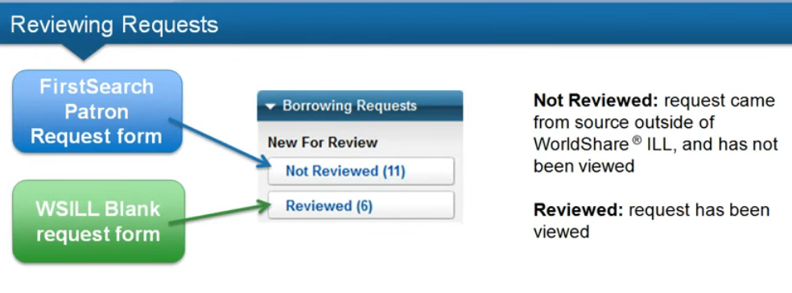

When creating a request please be sure to include your constant data – it will allow shorten the turn-around time for your request.
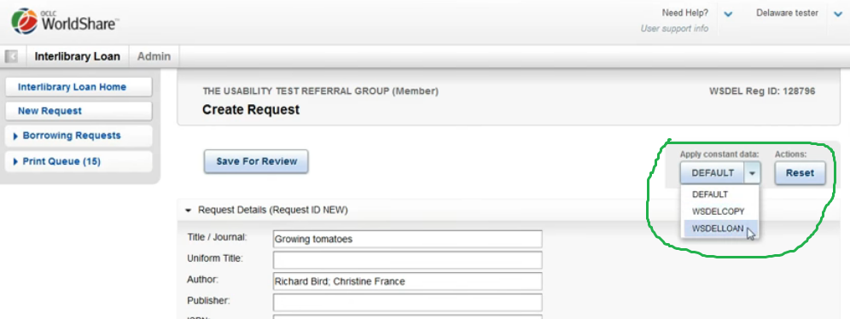

You can add your patron information to the patron section – this will only be seen by you. The lender will not be able to see it. Then choose the “Mark as Reviewed” button.
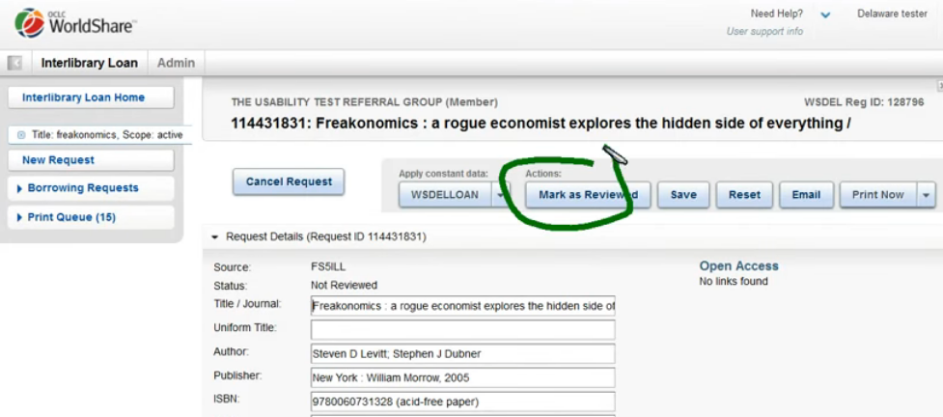

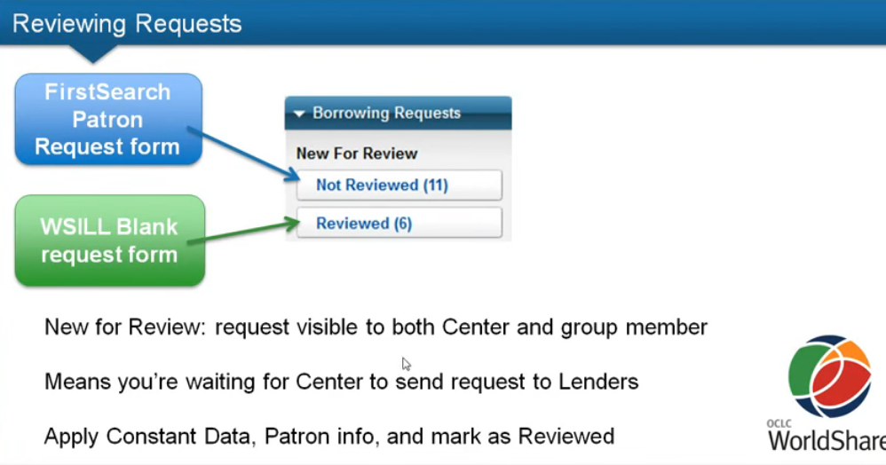

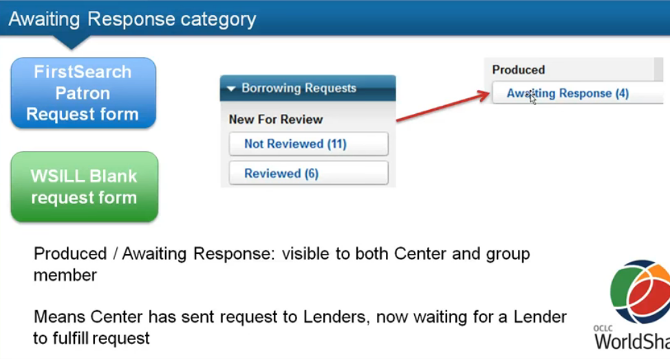

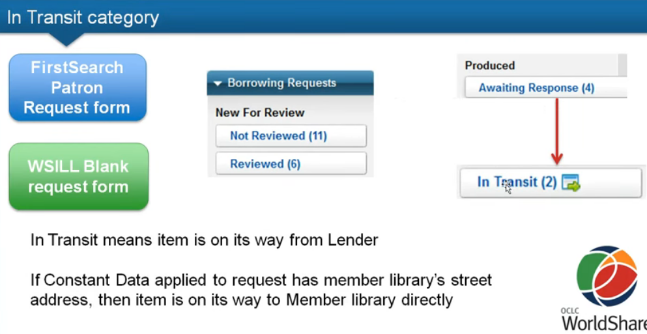

Emailing requests increases processing time by quite a bit. Please only email if WorldShare ILL is down.

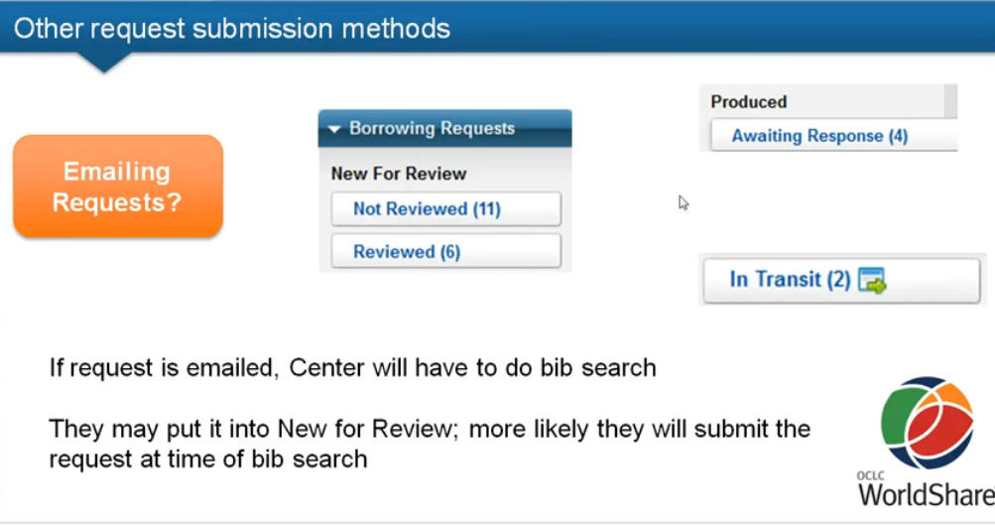

If you want to check the status of a request there are many ways to search for it using the search box on the Interlibrary loan home page:

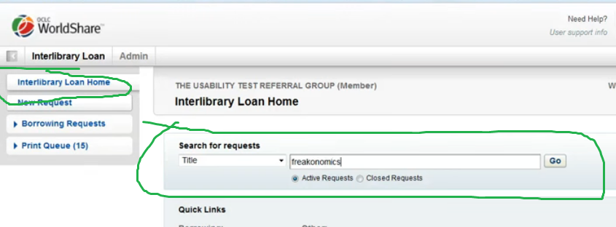

When you have a request open, if you scroll to the bottom, you will be able to see the various responses from lenders under “request history”:
