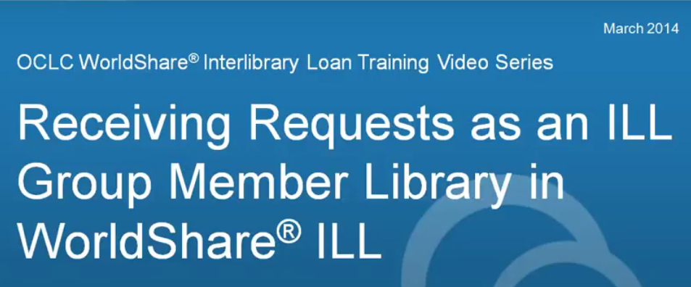

When your item arrives from the lender you will need to mark it as received in WorldShare ILL.

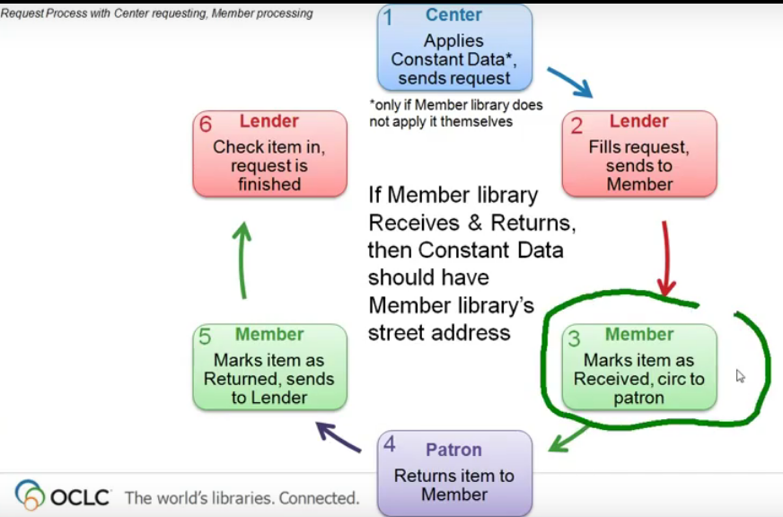

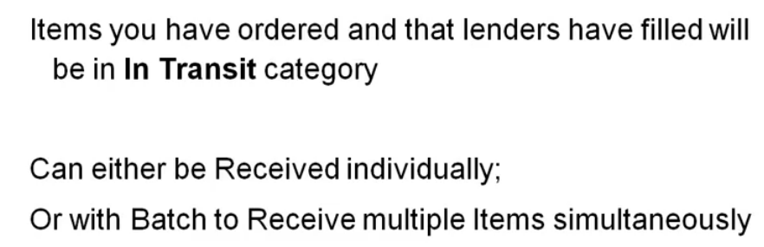

Your ‘Produced’ queues will show items that we have sent to lenders for you:

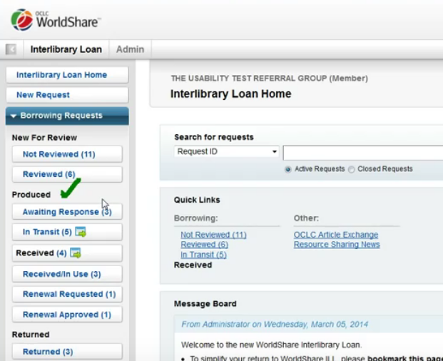

The ‘in transit’ queue has items that lenders have sent to you in the mail but that you have not yet received.
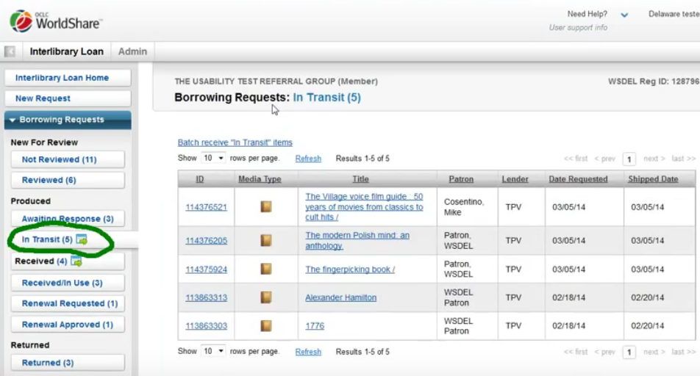

When a requested item arrives click on the request title or ID # in the ‘in transit’ queue:

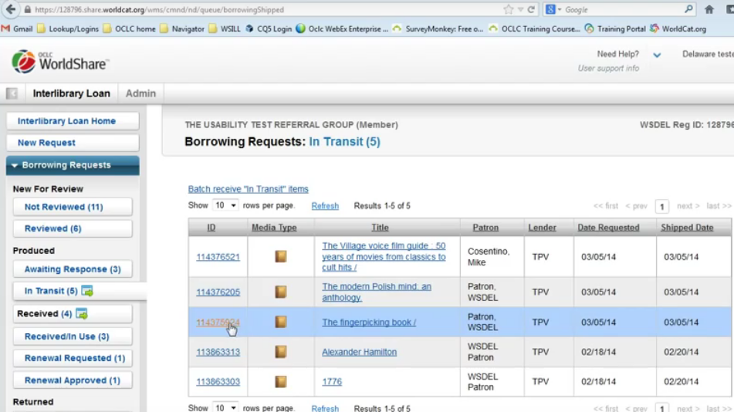
You have the option to print a book strap for the item that will show the due date, request ID #, etc. If you wish to print this please mark the box next to the option BEFORE marking as received. You can either print it now or add it to the print queue.
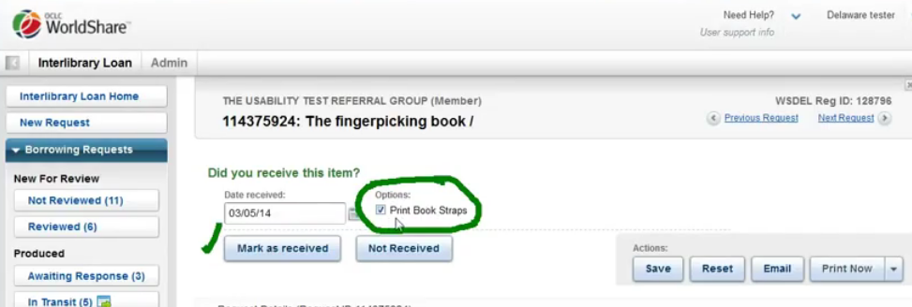
Choose your print option BEFORE marking as received.
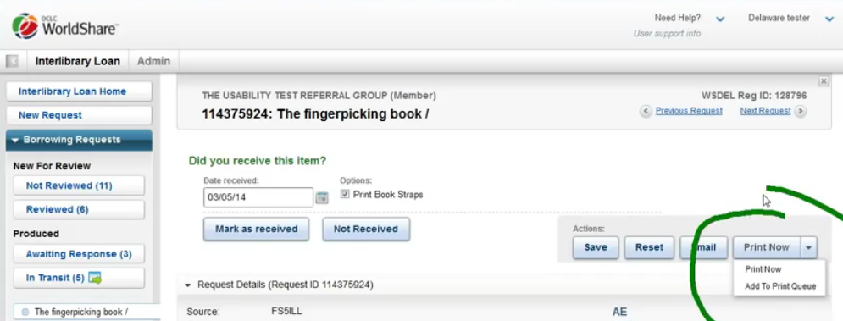
Choosing ‘print now’ will open a dialogue box:
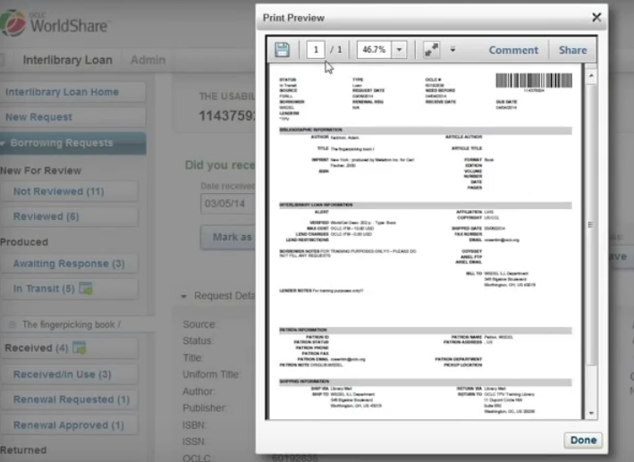
You can then send the item to the printer:
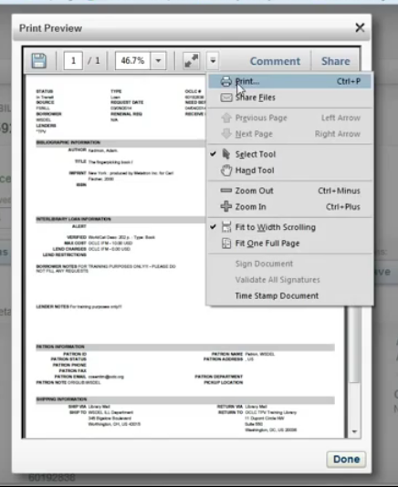

Click the “Mark as Received” button:
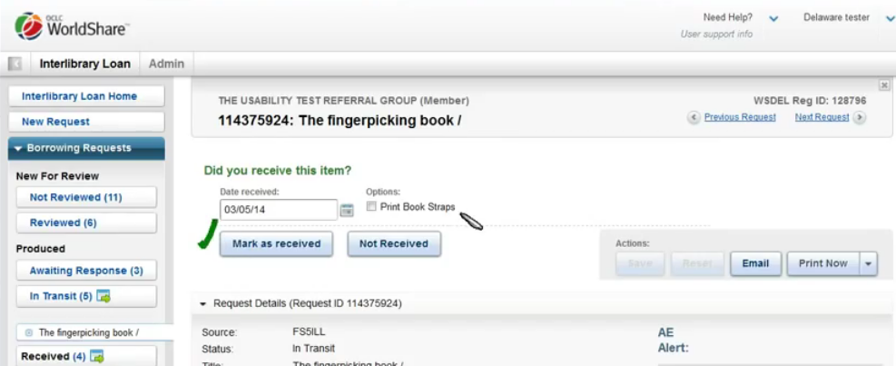
You will get a confirmation that the item has been received:
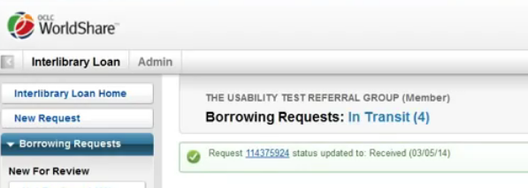
The request will now move from the “In-transit” queue to the “Received In-use” queue where it will stay while in use by your patron:

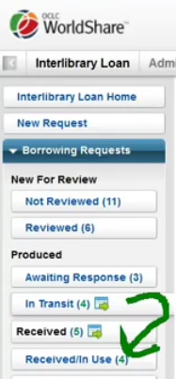
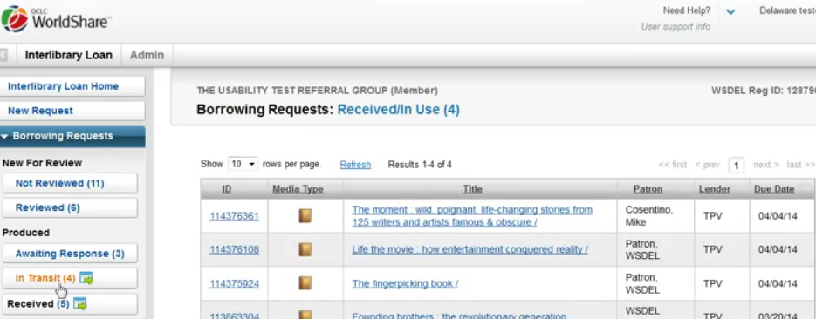

Batch processing is available on the ‘in transit’ queue:
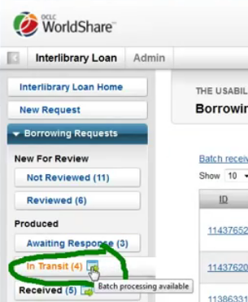
Click on the “Batch receive In Transit items” button – this will open a ‘batch’ section.
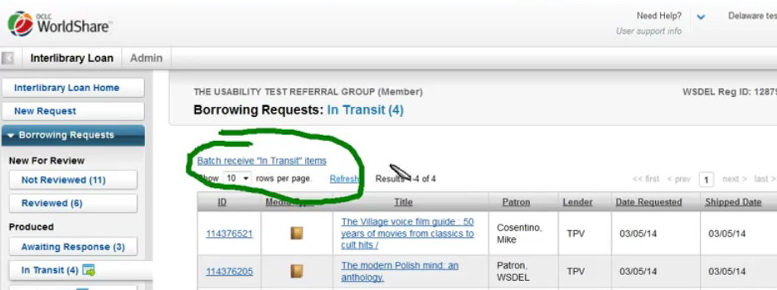

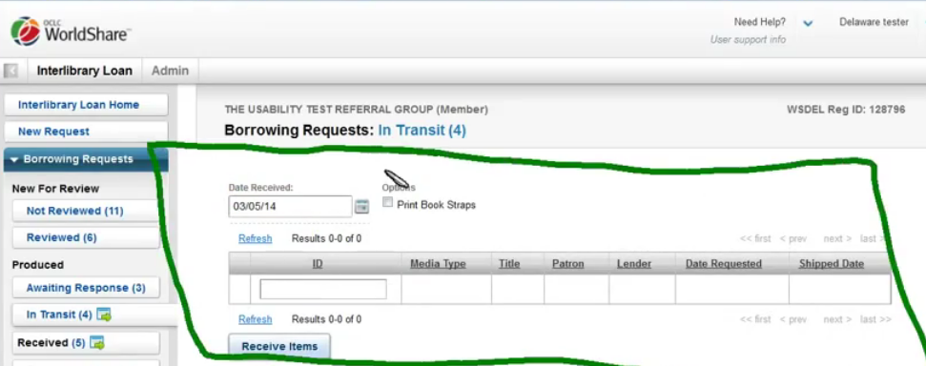
You can scan or type in the request ID number:
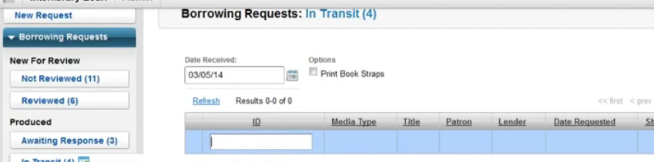
That will move the item from the queue below to the queue above:
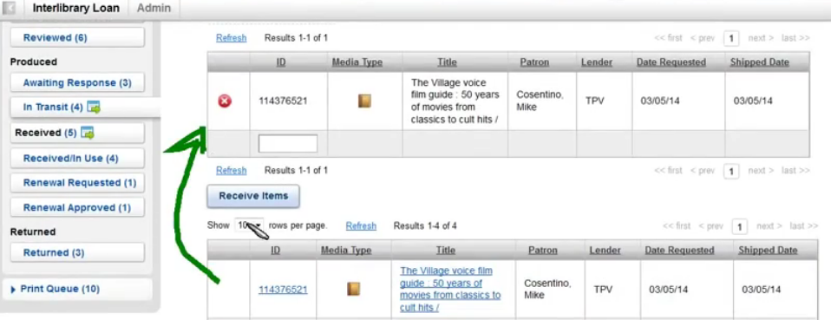
Or you can click the green plus sign to move the item to the queue above:
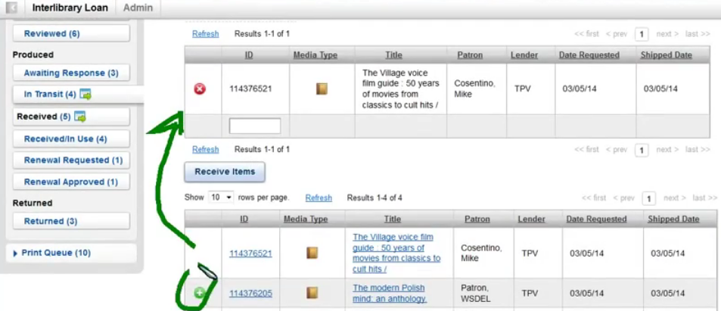
You can now print book straps for all of the queued items:
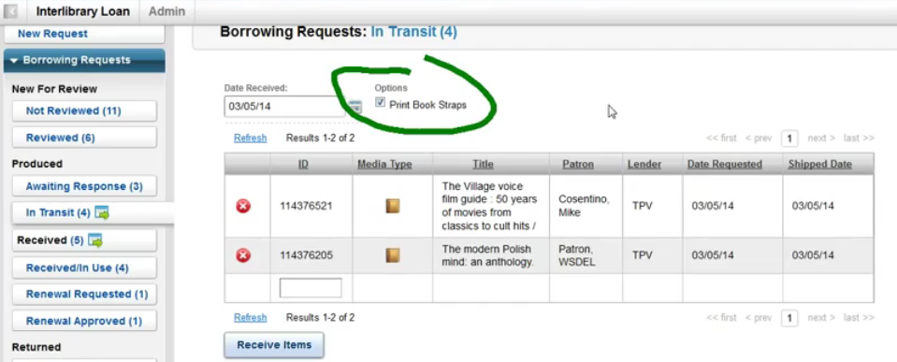
Click “Receive items”
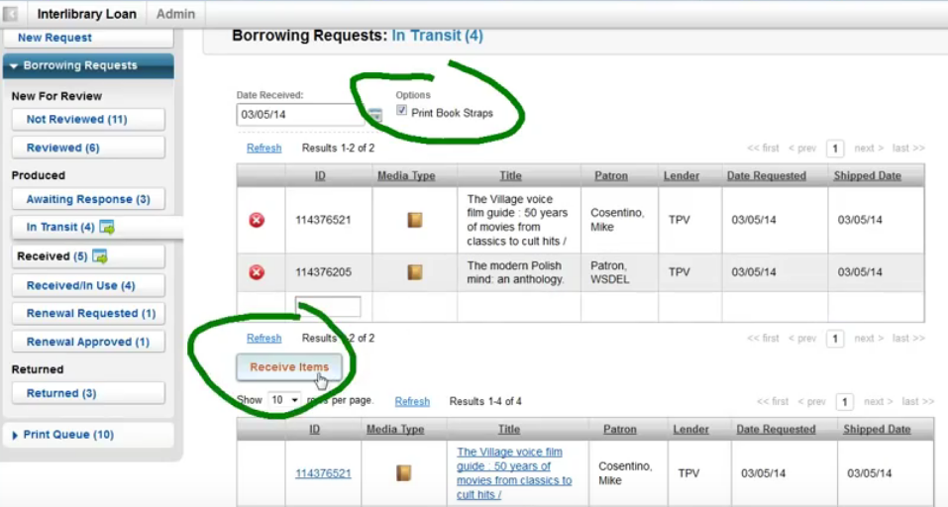
You will see confirmation of what you requested:
