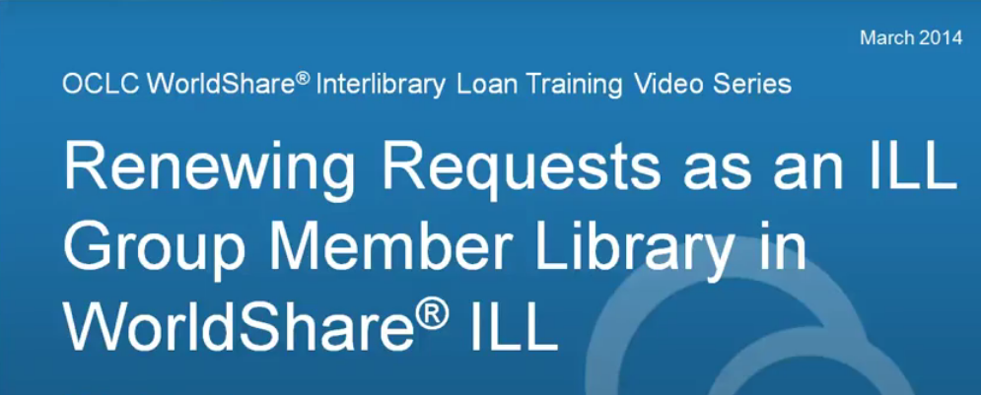

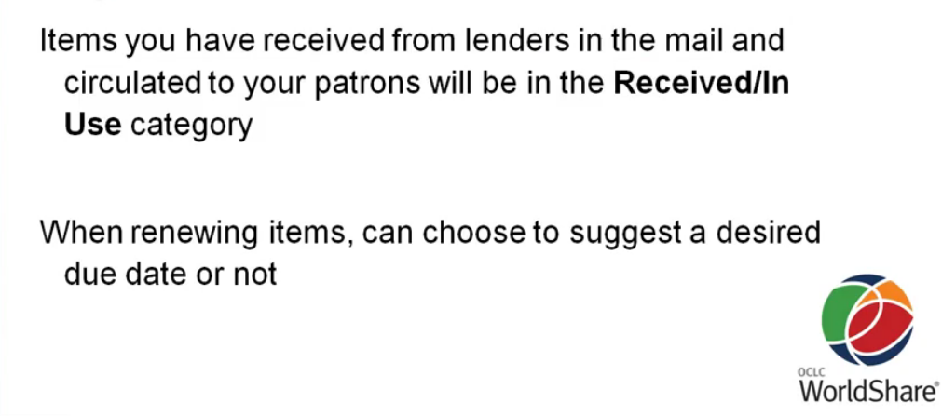

There are several queues for renewals.

Renewals Requested -- you have requested renewals for these items – still waiting for the lender to respond
Renewal Approved – queue for renewals that have been approved.
Renewal Denied -- queue for renewals that have been denied.

An item must be in the ‘received/in use” queue to request a renewal.
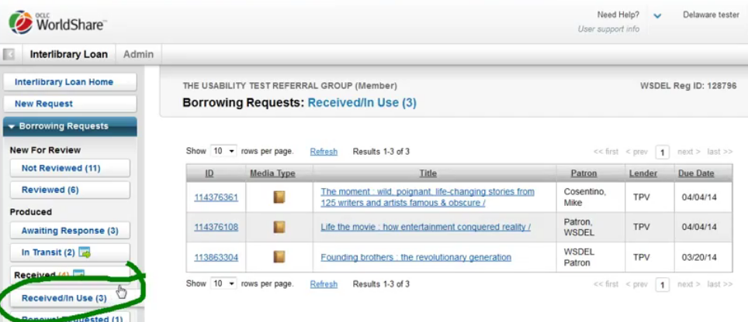

To request a renewal, select the item you wish to renew by either ID # or title:
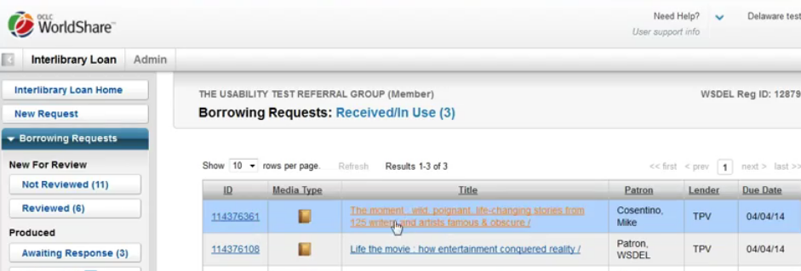

Or, you can go to the Interlibrary loan home screen and search for an item by one of the various options:
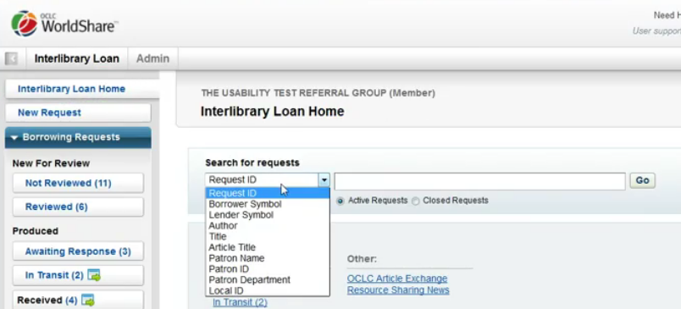

Once you are in the request you can see the due date and lender information by scrolling to the “request details’ area:
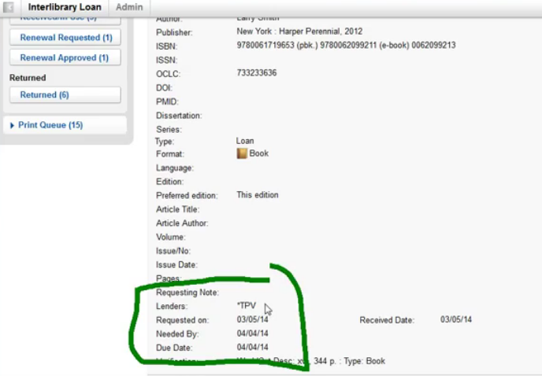

At the top of the request you will see the renewal button:
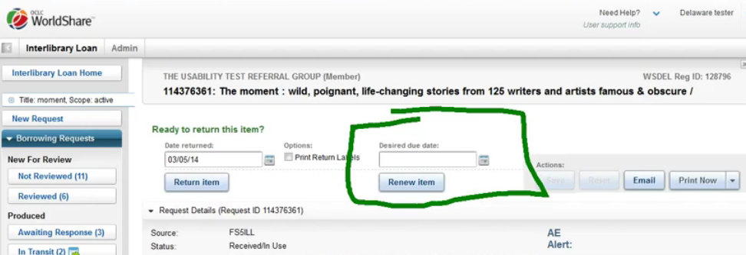

You can enter your desired due date or just hit the ‘renew item’ button. The lender will decide to approve/deny your renewal. The lender does not have to approve any renewals.
**We find that putting in a date can be helpful if you only need a few more days or a couple of weeks. Lenders are more likely to give you an extra week than to assume you are looking for another month because no desired due date was indicated.

Hitting the ‘renew item’ button will then move the item from the “received/in use” queue to the “renewal requested” queue.
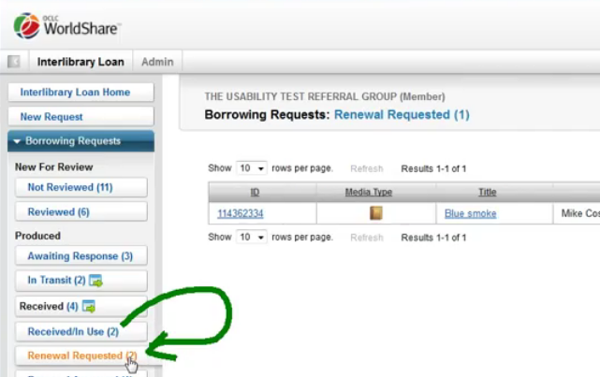

Once the lender responds the item will then move to the “renewal accepted” or “renewal denied” queue.
In the ‘renewal approved’ queue you will only see the original due date –
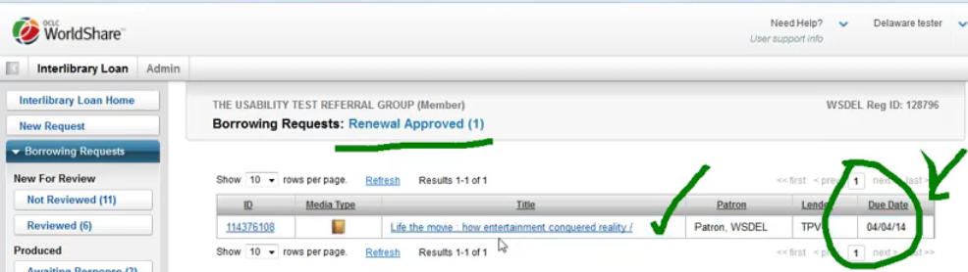

You need to open the individual requests to see the new due date by scrolling down to the request details area:
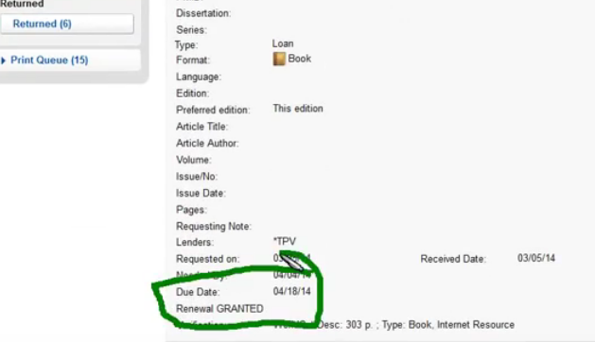

If a renewal is denied than the original due date still applies. It is very, very important that you and your patrons adhere to due dates. We do not want to hurt the relationships that we have maintained and prevent other patrons from borrowing.

