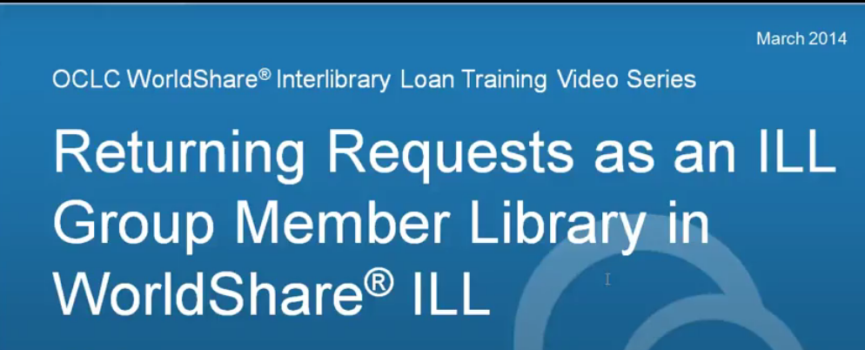
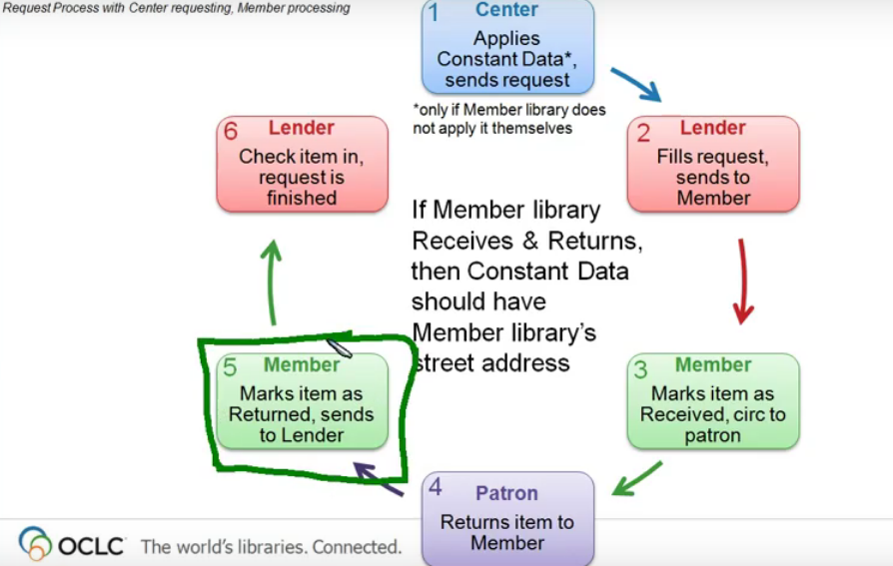

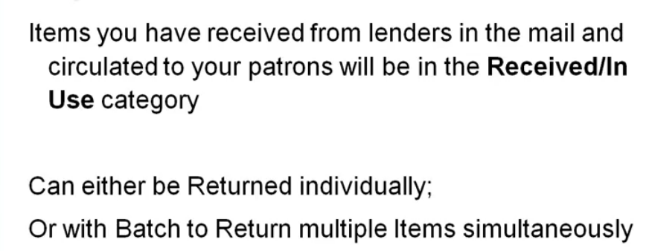

Looking at your ‘Received/In Use” queue you will see all the items that are now out with your patron.
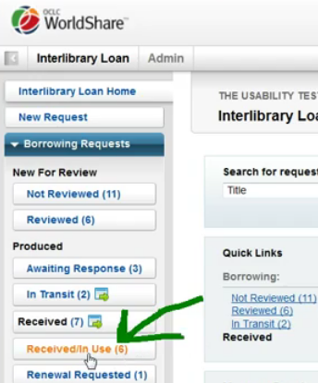

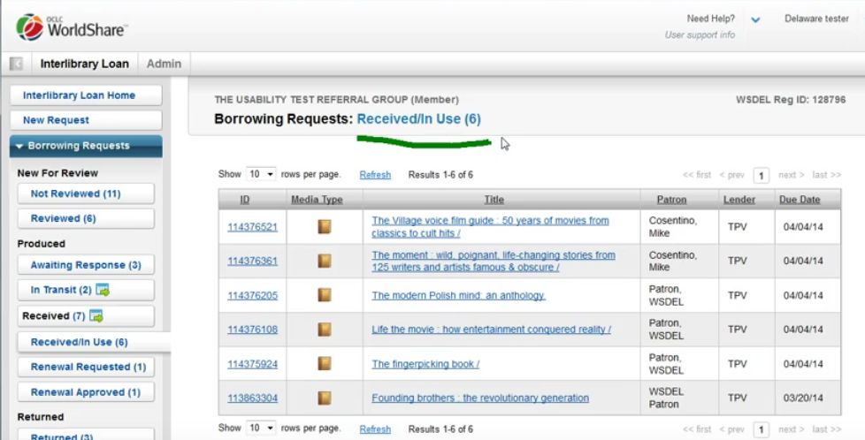

When your patron has returned an item, select it from this queue by clicking the title or ID # to open the request. From here you can see the ‘return item’ button. If you wish to print return labels you must do so BEFORE clicking ‘return item”.
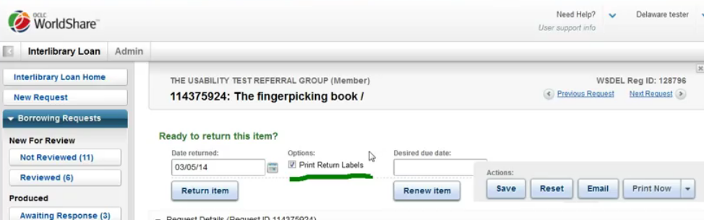

Scrolling down will allow you to see the lender symbol, due date, and return address:
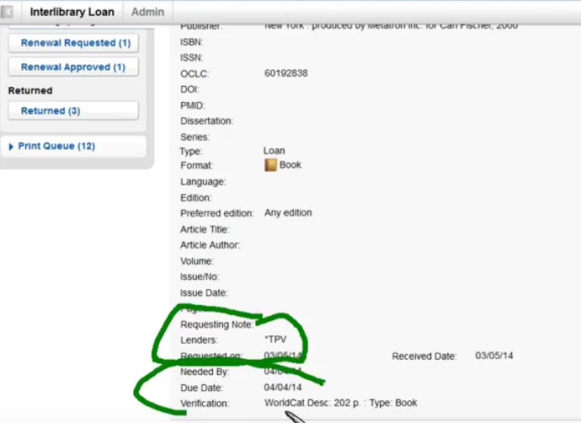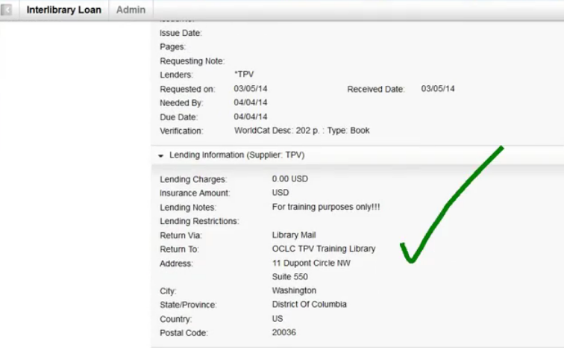

When you click the ‘return item’ button it will update the request status and add the return labels to the print queue. You will also get a confirmation that the item has been updated to returned:
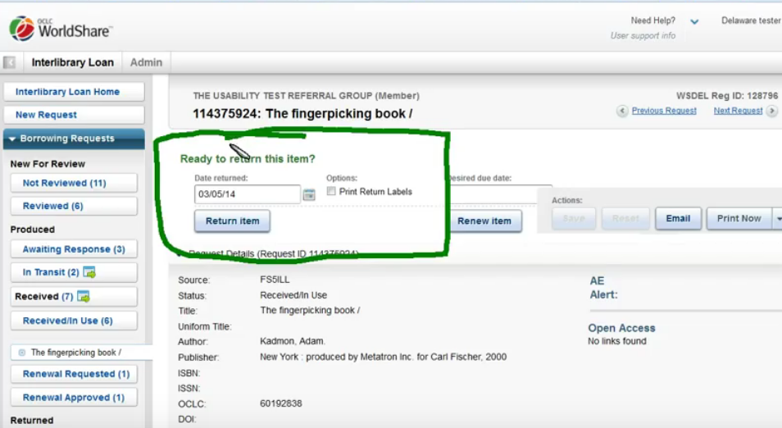
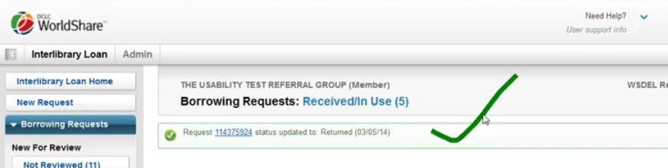

The request will move from the ‘received/in use” queue to the ‘returned’ queue:
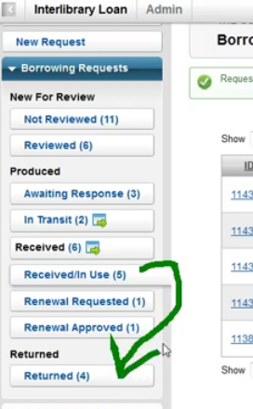

You can also ‘Batch return’ items by clicking on the “received/in use” queue and clicking the “Batch return received items” link:
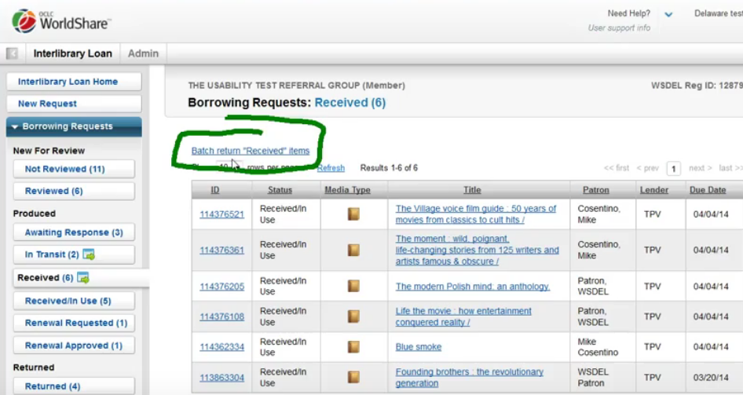

This will open up the batch section:
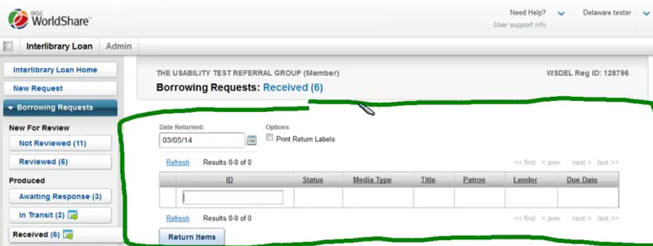

You can add items one at a time by clicking the green plus sign next to them. This will move the request from the queue below to the top queue:
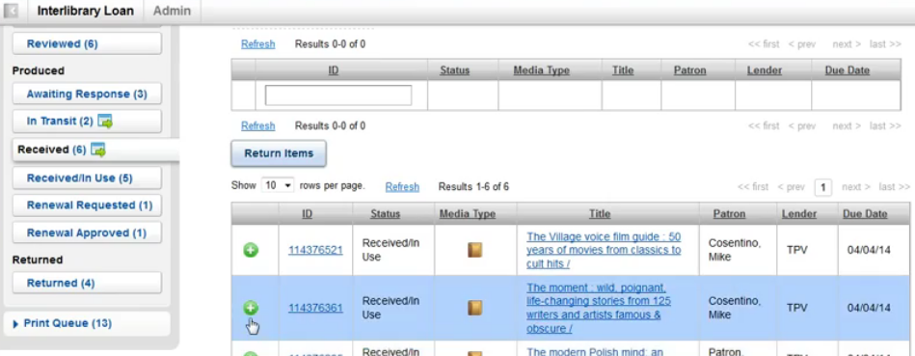

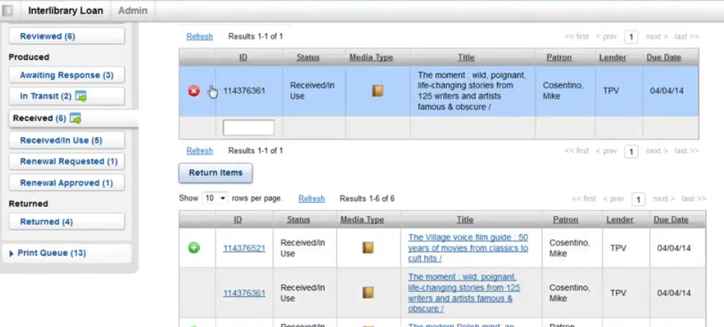

If you want to print return labels, please be sure to mark the box BEFORE hitting the ‘return items’ button.

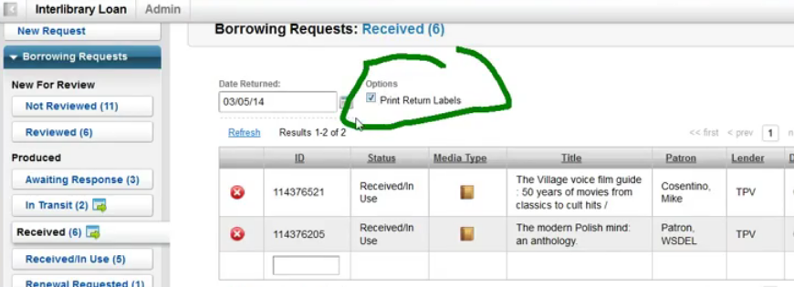

Click the ‘return items’ button and you will get confirmation of your actions – the requests will move from the ‘received/in use’ queue to the ‘returned’ queue:
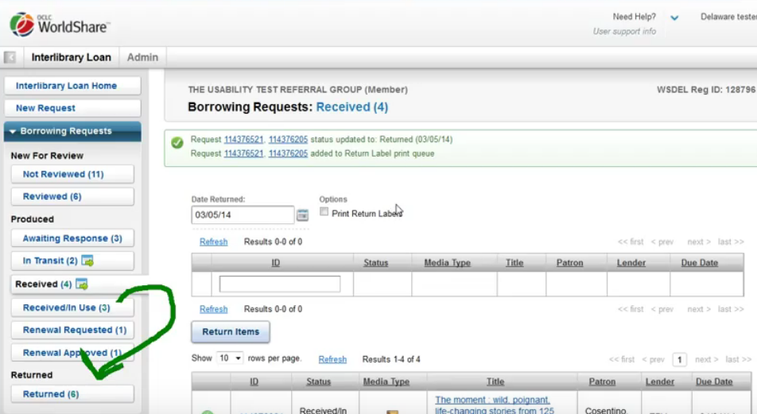

They will remain in the return queue until they have been checked in by the lender.

