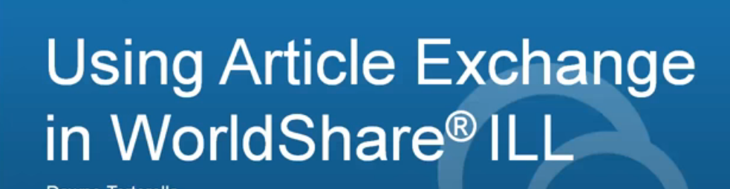

Articles, copy requests, chapters of books and periodicals are requested using Article Exchange whenever possible. Most lenders will upload a copy of your requested item for you, and your patron, to view.
You will be able to preview the item one time to make sure the copy is correct and legible. Once verification has been made you can email it directly to your patron. Your patron has up to 30 days to pick it up and is allowed 5 viewings.

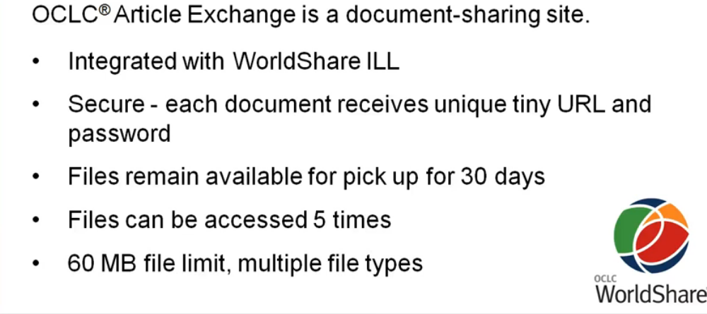

Multiple file types are supported – including .zip

When an article/copy is ready for pick up it will appear in your “AE Alert” queue.
This queue will only be seen if there are items in it.
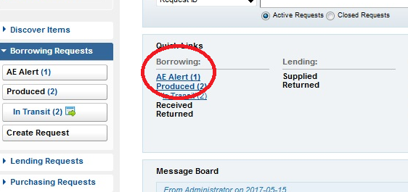

Click “AE Alert”. This will bring you into the queue.
Click the title or the ILL number of the request you want to preview. Please be sure to preview all items for accuracy before sending them to your patrons.
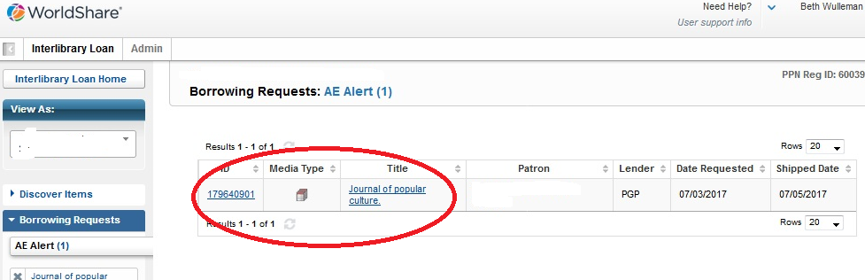

Click the “Preview” button to view the item that was sent.

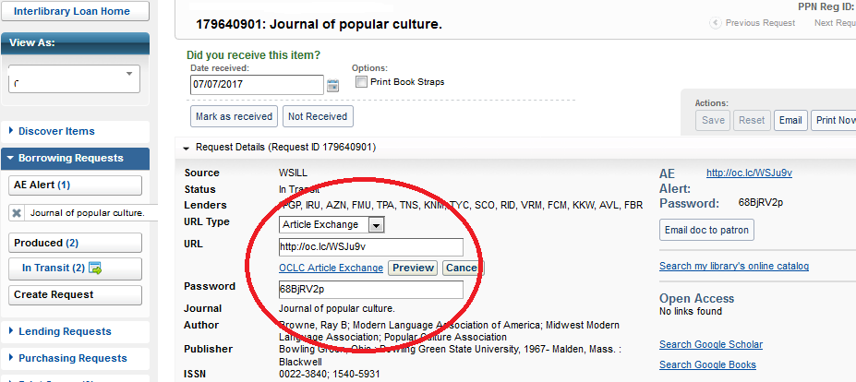

A window will appear with your document in it. You can scroll through the pages.
When you are finished click “done” and the preview window will close.
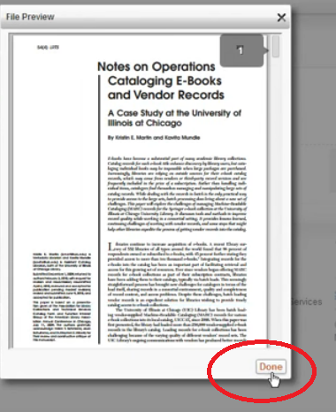

The preview button will no longer exist. You can email your patron the tiny URL and password so they can view it.

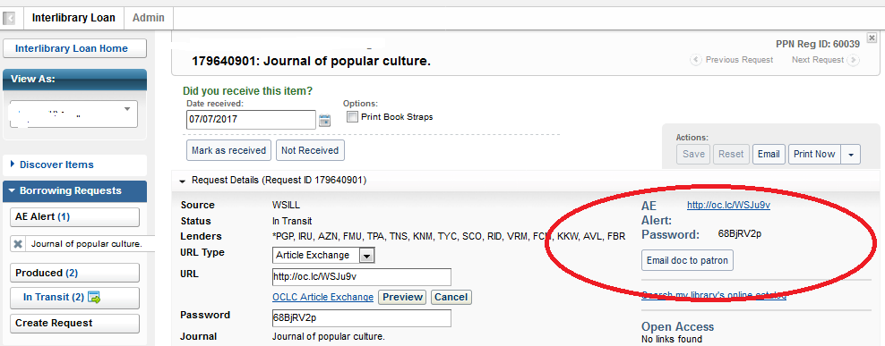
Clicking the “email doc to patron” button will bring up an email form – please be sure your email is added to the “from” field and your patron’s in the “to” field. The URL and password will auto-fill
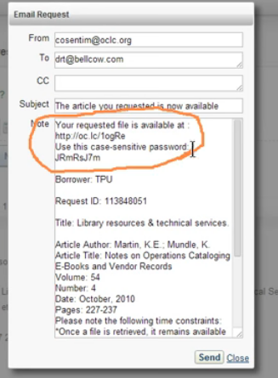
Click send – a confirmation box will appear:
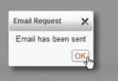

Once your patron receives it they may view it 5 times.
The next step is to mark the item as received so that the lender knows that you received the item and can collect statistics on their sent items.
