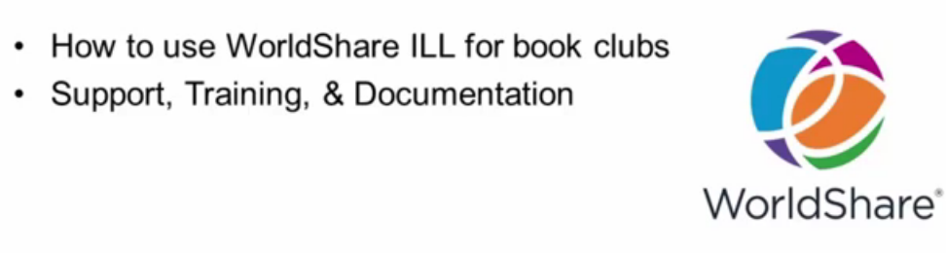

To enable this feature contact PPL and ask to have a new constant data record created for Book Clubs.

- From your home screen choose “Discover Items”. Search for the item you wish to request for the book club members – this search is conducted the same way regular loan requests are.
- Choose one of the item records produced through your search, change the Quantity needed from 1 to the desired number of copies and click “Create Request”
- Select the book club constant data from the top right:
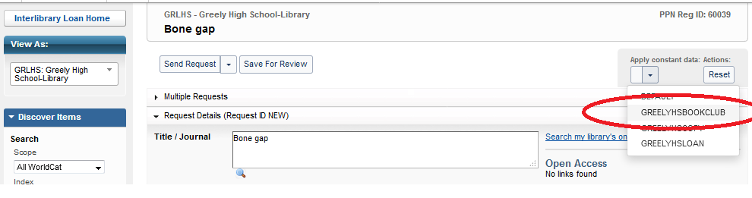
- Scroll down to the “Patron” section of the request and fill in the ‘Notes” field:

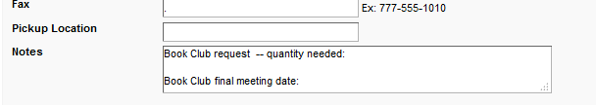

- Click “Send Request” and it will arrive at PPL.
Once PPL has processed your book club request a new queue called “Linked Requests” will be generated in the “Borrowing Requests” queue. Each copy of the item will be assigned its own ID #.
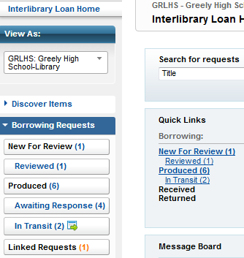

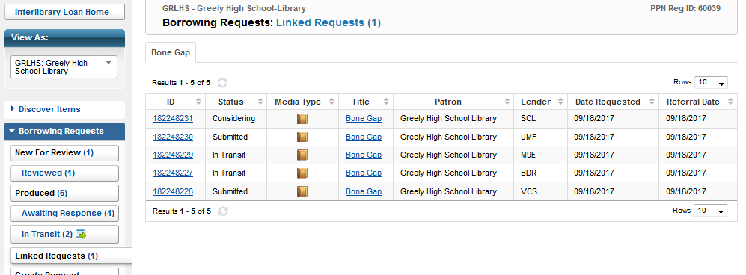

You may then monitor status updates /print book straps/print labels/request renewals for each item individually for just as you would any other request.

