If there are conditionals requiring your attention they will appear in the “Borrowing Requests” queue.
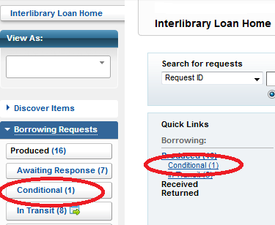
A conditional is a lender request for more information regarding your item request. A conditional may also be a lender asking if you will accept their borrowing terms.
To view the conditional, click on the link under “Borrowing:” This will bring you into the queue.

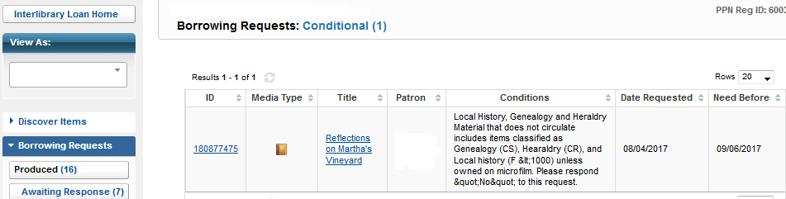
Here you will see the ILL #, item title and format, and the information from the lender.
In this example the lender is informing us that the item does not circulate. They are asking for a “no” response. In this case you would notify PPL to respond “NO” to this conditional.
Please contact Portland Public Library with your response. You can either email ill@portlib.org or call 207-871-1735.
Conditionals will expire in 4 business days and the request will move on to the next lender.
Saying “NO” to a conditional will move the request to the next lender or it will close the request if there are no more potential lenders.

PLEASE NOTE: Only Portland Public can respond to conditionals. You MUST let us know how you would like to proceed. Or you can wait the 4 business days until the request moves automatically to the next potential lender.
There are times when Portland Public will respond to a conditional on your behalf. This is in the best interest of your patron and will prevent delays in receipt of the item.
For example – you have specified $0 max cost and the conditional states the lender charges $15. We will say “No” and move the item along to the next potential lender.

Once Portland has submitted your response to the conditional the request will move into your “Borrowing” “Awaiting Response” queue. The status will say “Conditions Accepted”.

If you have any questions regarding conditionals please contact the ILL office at PPL.

