COPYRIGHT COMPLIANCE

Article and copy requests will require an indication that your request complies with United States copyright laws and guidelines. There are two valid codes: CCG and CCL.

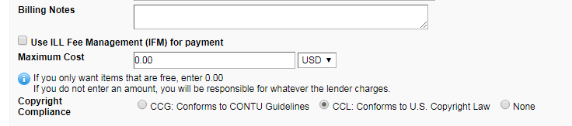

Portland Public library does not take responsibility for your copyright compliance and will reject requests that are missing a compliance selection. Please make a selection before submitting your request. You will not be able to add it later unless you contact PPL directly and ask the interlibrary loan office to update your request. Please contact Portland Public Library with your response. You can either email ill@portlib.org or call 207-871-1735.

CCG conforms to CONTU guidelines. http://www.ala.org/advocacy/sites/ala.org.advocacy/files/content/copyright/GLsInterlibLoan.pdf
CCL conforms to U. S. Copyright law
https://www.copyright.gov/title17/92chap1.html#107

